Content
ORDERS TO RECORD 1
I. OVERVIEW OF WEB PAGES 2
1. FEATURES OF WEB ACCESS 2
2. SYSTEM REQUIREMENTS FOR WEB BROWSING 2
3. LOGIN THE WEB BROWSING SESSION 3
4. BASIC COMPOSITION OF WEB PAGES 3
5. PAGE BUTTON INTRODUCTION 4
6. ERROR MESSAGES 4
7. ENTRY FIELD 5
SECOND, WEB PAGE INTRODUCTION 5
1. SYSTEM CONFIGURATION 5
2. PORT CONFIGURATION 9
3. VLAN CONFIGURATION 13
4. SAFETY CONFIGURATION 16
(1) MAC CONFIGURATION 16
(2) ACL CONFIGURATION 18
(3) AAA CONFIGURATION 23
(4) THIS MACHINE MANAGES SECURITY CONFIGURATION 25
5. MULTICAST CONFIGURATION 25
(1) IGMP SNOOPING CONFIGURATION 25
6. RELIABILITY APPLICATION 27
(1) CONFIGURATION OF SPANNING TREE 27
(2) ERPS CONFIGURATION 28
7. ADVANCED CONFIGURATION 31
(1) BASIC IP CONFIGURATION 31
8. SYSTEM TOOLS 33

WEB page operation manual
This manual mainly describes the WEB page switch. Users can pass through the switch
The WEB page is managed against the switch.This manual is only a brief introduction to the operation of each WEB page,
This manual mainly includes the following contents:
1. Overview of WEB pages
2. WEB page introduction

I. Overview of WEB pages

1. Features of WEB access
It is switch provides Web access for users.Users can access the switch through a Web browser to manage and configure the switch.The main features of WEB access are:
- easy to access: users can easy access to anywhere from the network switch.
- users can use familiar with Firefox, Google Chrome, Oprea and Microsoft Internet Explorer (version 8.0 and above), and other browse switches to visit the WEB page of a WEB page in the form of graphics and tables presented to the user.
- It is switch provides a rich WEB page, the user can through the WEB page for the most part facing the switch function configuration and management.
- The classification and integration of WEB page functions facilitates users to find relevant pages for configuration and management.

2. System requirements for WEB browsing
The system requirements for Web browsing are shown in Table 1.
Table 1:
Hardware and software | System requirements
The CPU | Pentium 586 and above
memory | More than 128 MB
The resolution of the | More than 1024 x768
color | More than 256 colors
The browser | Internet Explorer 8.0 or above or Firefox or Google Chrome or Opera, etc
The operating system | Microsoft® Windows XP ®/Windows Vista®/ Windows 7®/Windows 8®, Linux, Unix and other operating systems

Note:
Microsoft®, Windows XP ®, Windows Vista®, Windows 7®, Windows 8® are registered trademarks of Microsoft Corporation. All other product names, trademarks, registered trademarks and service marks are copyrighted by their respective owners.

3. Login the WEB browsing session
Before starting a Web browsing session, the user needs to confirm:
-   have IP configuration on the switch, by default, the switch is 192.168.0.1 VLAN1 interface IP address,
- The subnet mask is 255.255.255.0.
-   have a 7-day host connected to the Internet, with Web browser and the host to PING switches.
-   after completion of above two tasks in the address bar of the browser the address of the input switches and press enter to enter the switch after login Web page, as shown in figure 1.You can access the Web only if you enter the correct password. The default user is ADMIN and the default password is empty.

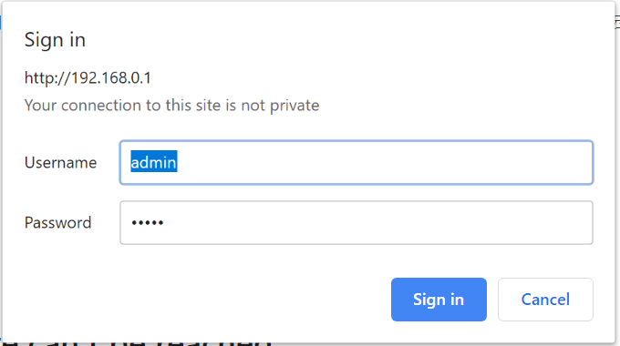
Figure 1. The login page for a WEB browsing session

4. Basic composition of WEB pages
As shown in Figure 2, a WEB page is mainly composed of four parts: the title page, the category navigation page, the menu page, and the home page.
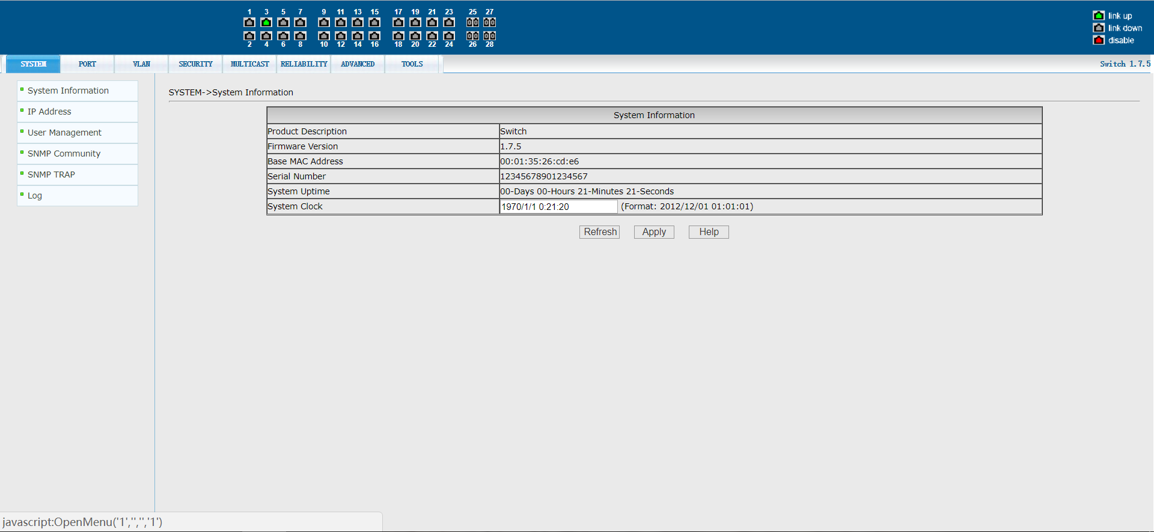

Figure 2 The basic components of the switch WEB page

The title page is used to display the logo, as well as the real-time port status, as shown below
The green light indicates that the port is connected;
The gray light indicates that the port is not connected;
The red light indicates that the port is closed
The classification navigation page is the functional classification entry of WEB. Users can click a button to view the corresponding classification menu. On the right side of the page is the model version of the switch and the login user name.
The menu page displays the category menu selected by the user from the category navigation page, which may have a first-level or second-level menu. Click the menu item to open the corresponding page.
The main page is used to display the page that the user selects from the menu page.

5. Page button introduction
There are some common buttons on the page, and the functions of these buttons are generally the same. Table 2 describes the functions of these buttons.
Table 2:
button | role
The refresh | Update all fields on the page
application | Put the updated value in memory. Because error checking is done by the Web server  Ok, so there is no error checking before the user selects the button
delete | Delete current record
help | Open the help page and view the configuration instructions for each page

6. Error messages
If the switch's WEB server fails while processing a user request, an error message is displayed in a dialog box.For example, Figure 4 shows an error message dialog box.
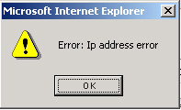
Figure 3: Error message page

7. Entry field
Some pages have an entry field at the beginning, as shown in Figure 5, through which different entries can be accessed.When you select a value for the entry field, the corresponding information for that row is displayed on the page, and the contents of that row, also known as the active row, are edited.
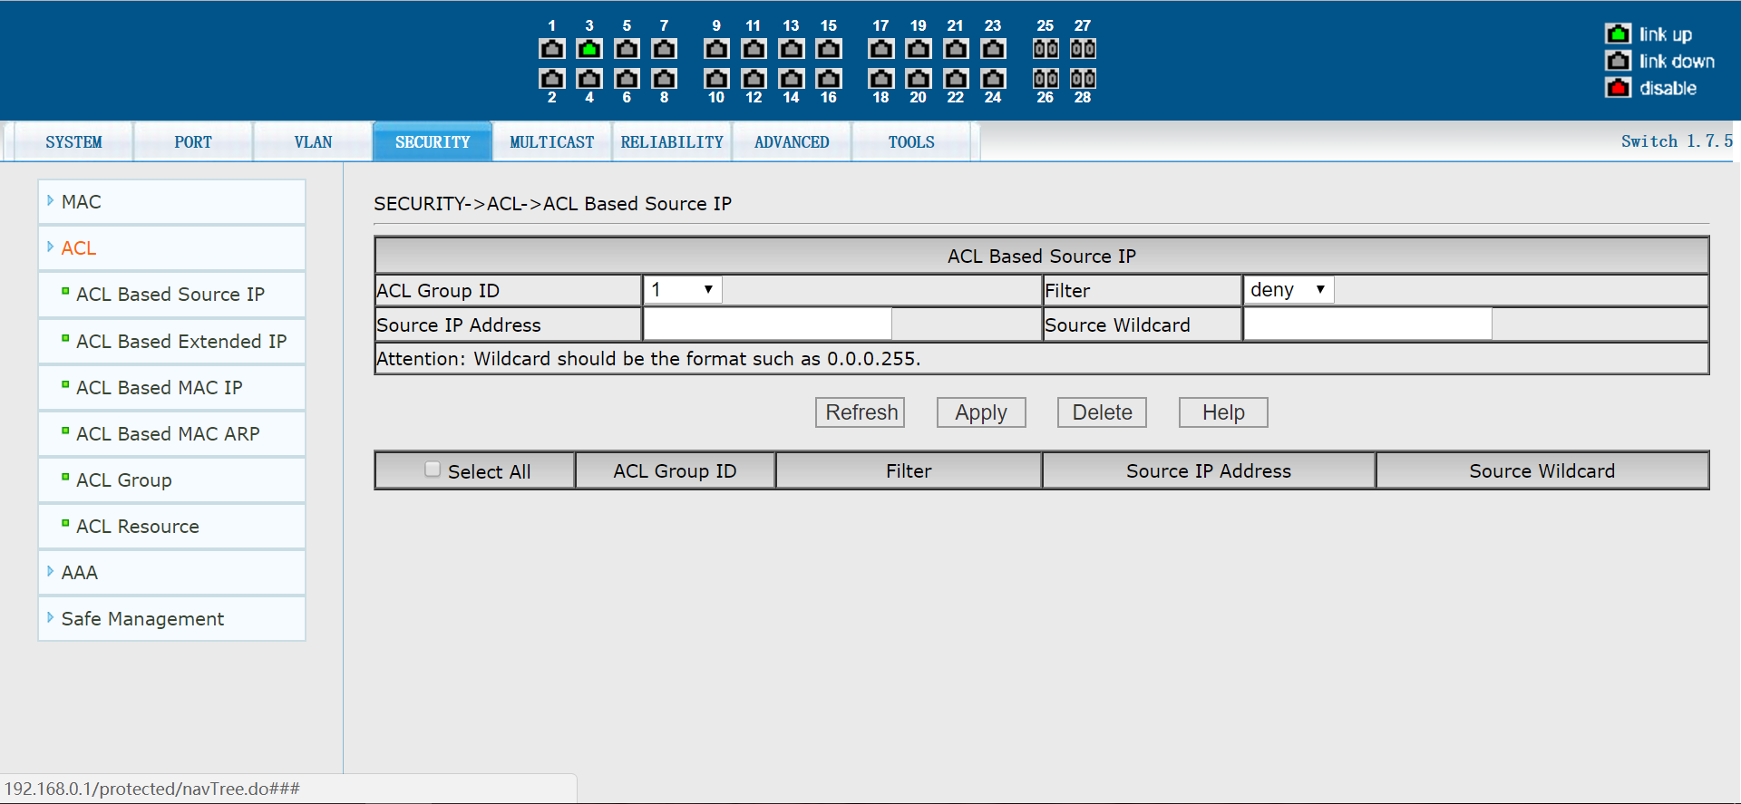
Figure 4 Entry domain page

Second, WEB page introduction
The WEB pages switch are organized into groups, each consisting of one or more WEB pages.Each page is described one by one.

1. System configuration
(1) System information page

Figure 5 is the system information configuration page, through which users can configure and view the system information of the switch.
Product model: Product model description of the switch
Firmware version information: the current firmware version used by the switch
Bootrom version information: The current version of Bootrom used by the switch
Benchmark MAC address: The benchmark MAC address of the switch
Serial number: The serial number of the switch
Serial port Baud rate: the serial port Baud rate used by a switch
System startup time: the time from switch startup to the present
System clock (modifiable) : The current clock of the system, which requires input of year, month, day, hour, minute, and second parameters
Figure 5 basic Information page

(2) IP address configuration page

Figure 6 is the IP address configuration page. Users can configure the IP address, subnet mask and gateway address of the switch through this page. The management VLAN defaults to 1 and cannot be modified.
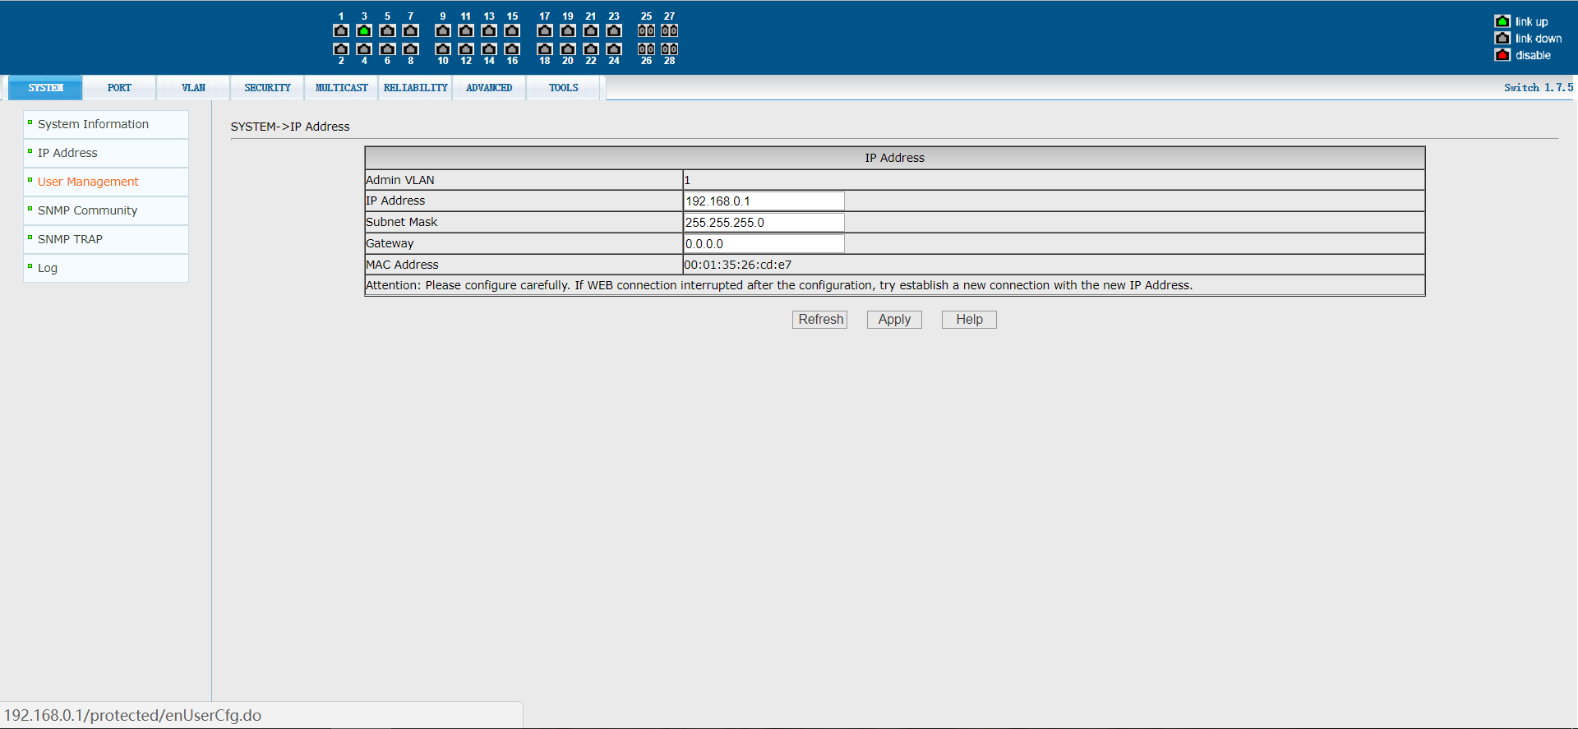
Figure 6 IP address configuration page

(3) User management page

Figure 7 is the user management page, through which user information can be configured. The default user of the switch is ADMIN, which cannot be deleted, but the password can be changed.
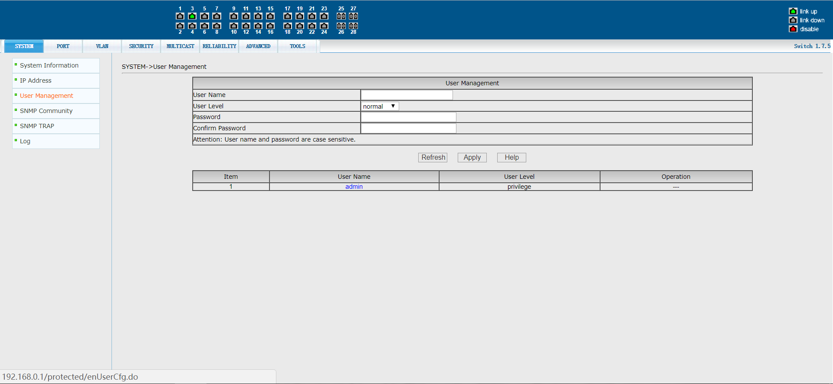
Figure 7 user administration page

(4) SNMP common body configuration page

Figure 8 is the CONFIGURATION page for SNMP shareware. This page allows users to configure the name and read/write permission of the shareware of the switch. A total of 8 entries can be configured.
By default, the switch has a shared-body with the public name, which is read-only.When the switch needs network management through SNMP, it needs to configure a common body of readable and writable permissions.
A configured shareware cannot be modified, nor can it be added with a duplicate name. You can, however, click the appropriate delete link to remove the Commons and reconfigure it.
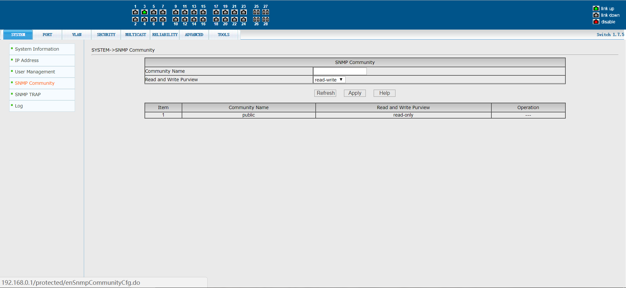
Figure 8 SNMP Common body Configuration page

(5) CONFIGURATION page of SNMP TRAP

Figure 9 is the SNMP TRAP configuration page, which allows users to configure the IP address of the workstation receiving TRAP messages as well as some parameters of the TRAP protocol package.
Enter the TRAP name, TRAP server IP address, and select the version number. After submission, if the configuration is successful, the SNMP TRAP function will play a role. Once the Link up or Link down occurs, the switch will automatically send TRAP packets to the target address.
Configured TRAP targets cannot be modified, nor can they be added with duplicate names.However, you can click the corresponding delete link to remove the TRAP target and then reconfigureit.

Figure 9 SNMP TRAP configuration page

(7) Log information

Figure 10 is the log information page, where users can view the log.Select a priority from the drop-down list to view the logs at that level, and click Refresh to view the most recently recorded logs.
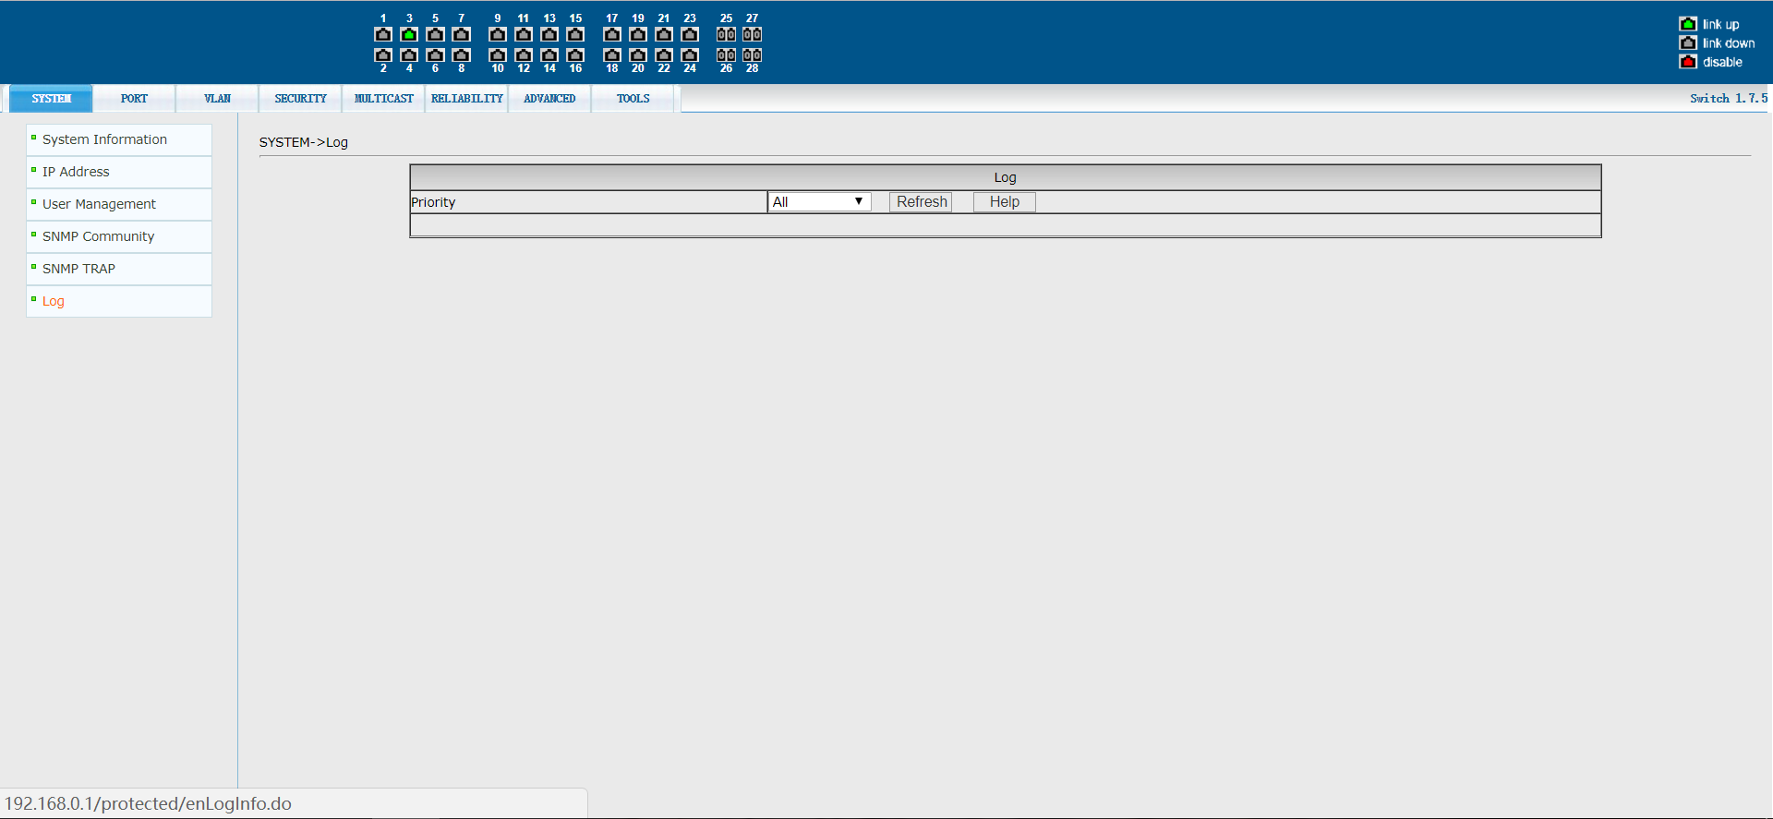
Figure 10 Log information page

2. Port configuration
(1) Port basic configuration page

Figure 11 is the basic port configuration page.This page allows users to enable or disable ports, set port rates and streaming, or view basic information about all ports.
To modify the port configuration, the user needs to check on the left side of the corresponding port, or use the "all check" function. The selected port will be displayed at the top of the page, with successive ports represented by connection Numbers.After successful setup, the selected port will be configured with the same parameters.The list on the page shows configuration information for all ports.
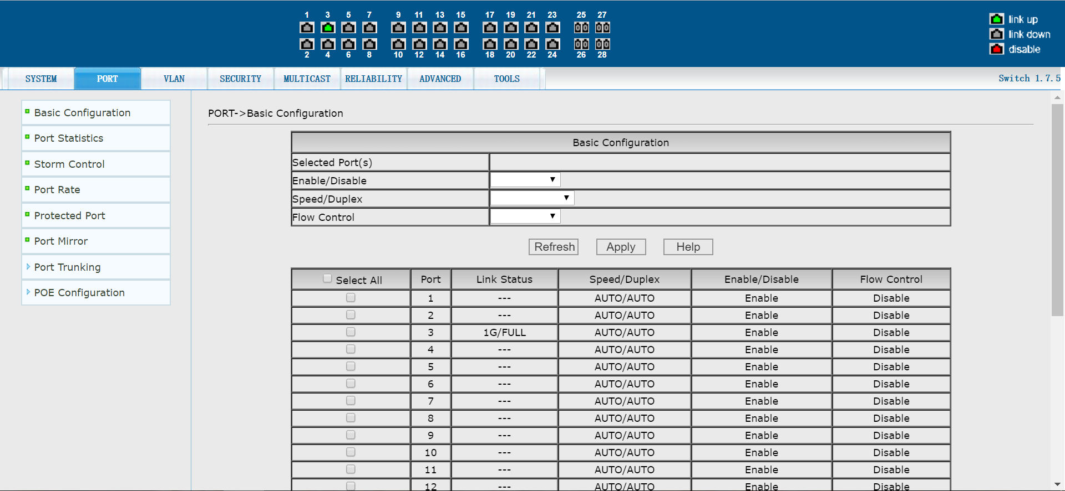
Figure 11 port configuration and port display page

(2) Port statistics page

Figure 12 is the port statistics page.The page lists the number of sent packets, sent bytes, received packets, received bytes, error packets, and dropped packets for all ports.
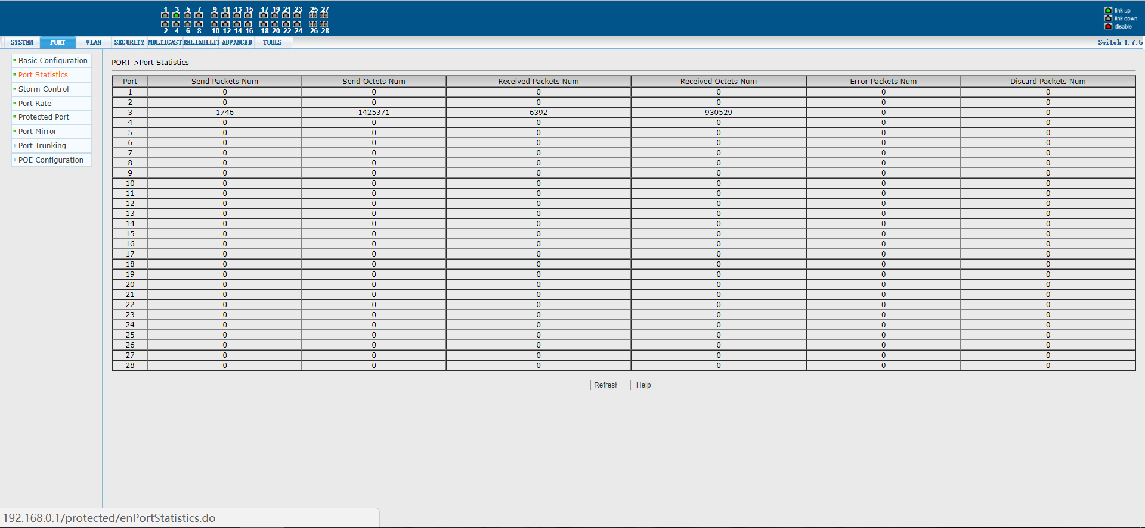
Figure 12 port statistics page

(3) Port storm suppression page

Figure 13 shows the port storm suppression page.This page is used to configure the port to suppress broadcast packets, multicast packets, and DLF packets.
Check the left side of the corresponding port, or select the port with the "select all" function to open and close the broadcast suppression, multicast suppression and DLF suppression of the port.The inhibition rate type item and the inhibition rate item were used to select the inhibition rate type and value to be configured, with the inhibition rate ranging from 1 to 1024,000, in kbits.The inhibition rates of port broadcast inhibition, multicast inhibition and DLF inhibition can be independently configured.The list on the page shows configuration information for all ports.
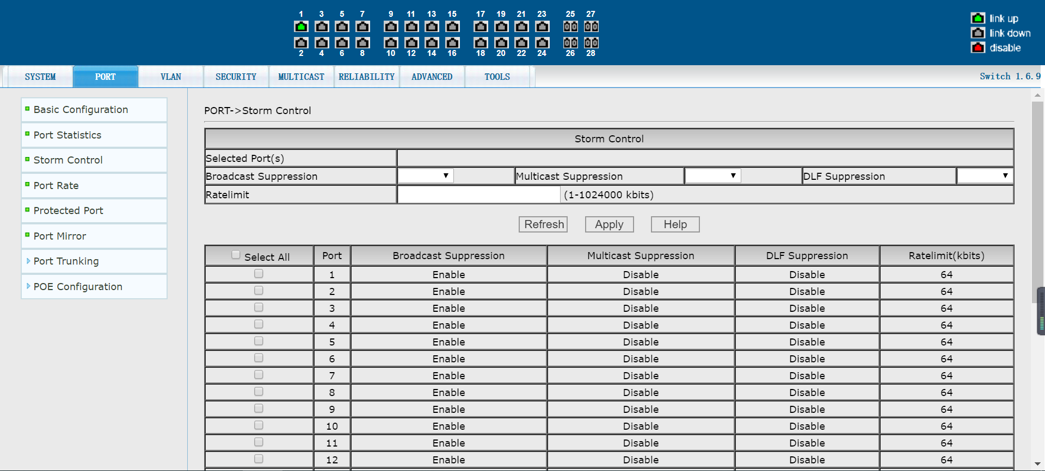
Figure 13 Broadcast storm suppression page

(4) Port speed limit page

Figure 14 shows the port speed limit page.This page is used to configure the port access speed limit.
Check the left side of the corresponding port, or select the port by using the "select all" function. The speed limit of inlet/outlet port can be opened separately by checking the box. The speed limit range is 1-1024000 and the unit is Kbits.The list on the page shows configuration information for all ports.
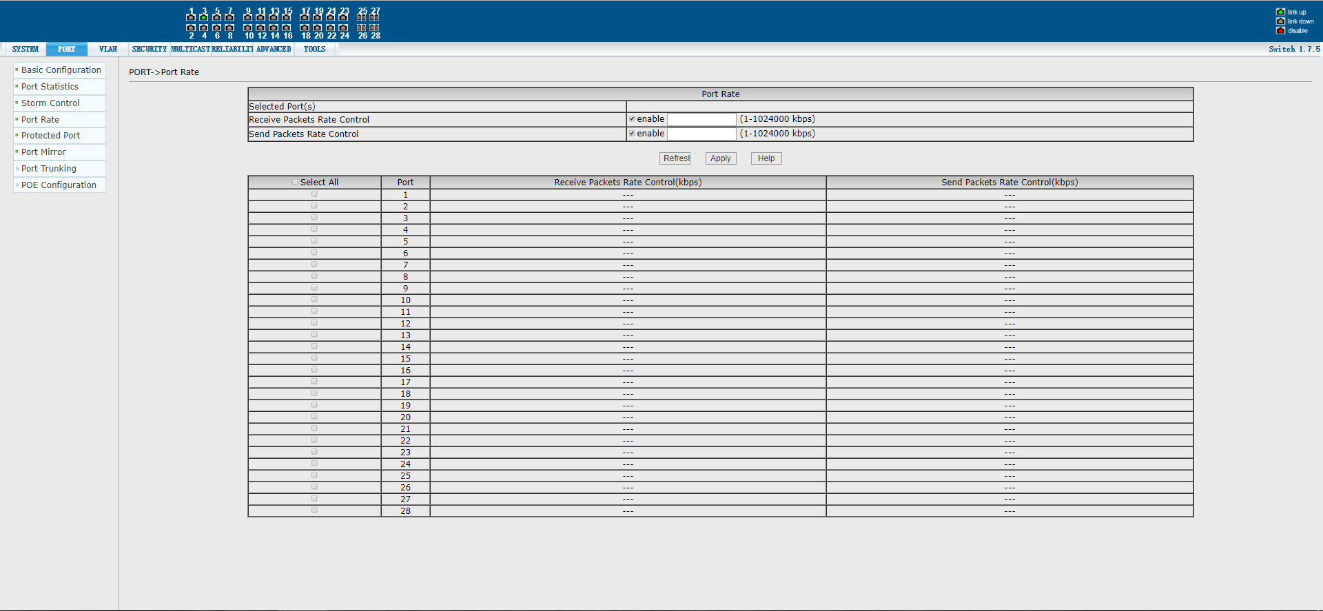
Figure 14 Port speed limit page

(5) Link aggregation configuration page

Figure 15 shows the link aggregation configuration page.The page lists all ports vertically and all aggregation groups horizontally. To add a port to an aggregation group, click the radio box at the intersection of the row and column, and select the aggregation method at the bottom of each aggregation group.To cancel the aggregation configuration for the specified port, click the leftmost radio box for the port.
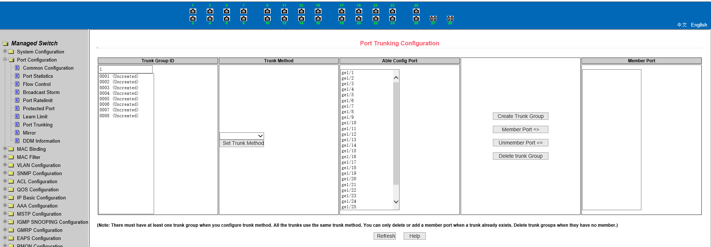
Figure 15 Link aggregation configuration page

(6) Port mirroring configuration page

Figure 16 shows the port mirroring configuration page, which allows users to configure port mirroring.Port mirroring is used to listen on the output port of the mirrored output port and the input port of the mirrored input port. Only one mirrored port can be selected, while multiple mirrored output ports and mirrored input ports can be selected. To configure, select a mirrored port, and select "not mirrored" to cancel the mirroring configuration.Then select the mirrored port and direction from the other ports.When selecting the incoming port in the direction of listening, the incoming port means listening for the received packets, the outgoing port means listening for the sent packets, and all the sent and received packets are monitored by checking
The box.
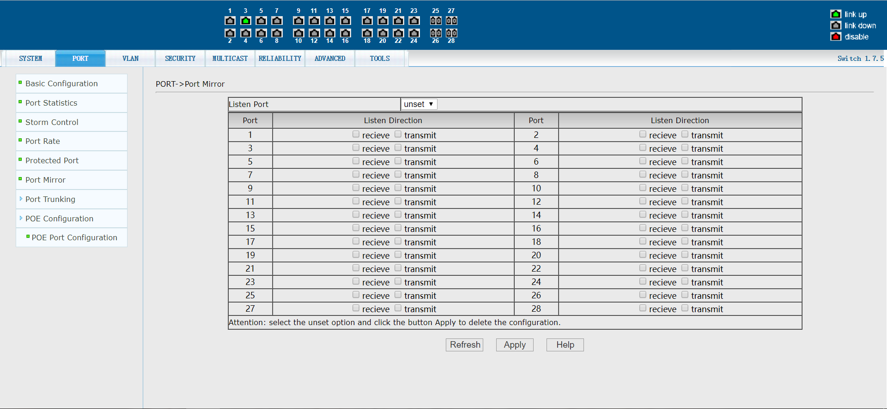

Figure 16 port mirror configuration page

3. VLAN configuration
(1) VLAN configuration page

Figure 17 is the VLAN configuration page.This page allows the user to create vLAns and display information for all VLAns.
If you want to create a new VLAN, type the VID on the active line, ranging from 2 to 4094.The switch creates VLAN1 by default, and VLAN1 cannot be deleted.
To delete a VLAN, click the corresponding delete link in the VLAN list.Click the Delete All button to delete all vLAns except VLAN1.
The VLAN list shows all vLAns that have been created and identifies each VLAN port member. A port can be either a VLAN member, tagged member of the VLAN, or an untagged member of the VLAN.The characters in front of the port of the page mean the following:
T Tagged this port is a tagged member of the VLAN
U Untagged port is an untagged member of this VLAN
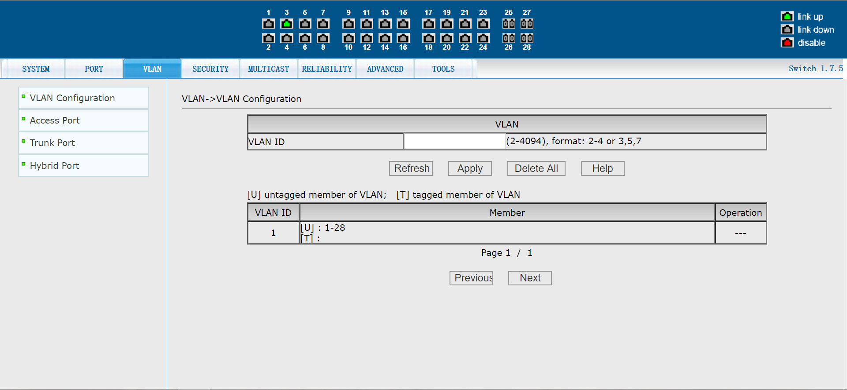

Figure 17 VLAN configuration page

(2) Access port configuration page

Figure 18 is the Access port configuration page, showing and configuring the port Access mode and the VLAN to which it belongs.The page is divided into two parts: port list and VLAN list. Hover the mouse over the port to see the VLAN mode of the port. Click on a port to display/configure the VLAN of the port.If the port is in Access mode, its VLAN is displayed when checked, and other VLAns are checked and applied, that is, the VLAN that has changed the port.If the port is not in Access mode, the port is configured in Access mode and the VLAN is set.Note that only one VLAN can be selected in Access mode.
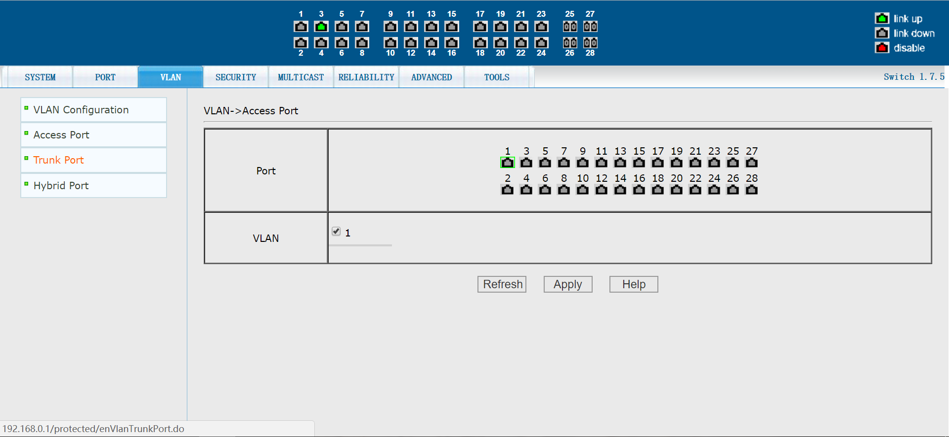
Figure 18: Access port configuration page

(3) Trunk port configuration page

Figure 19 is the Trunk port configuration page, showing and configuring the port Trunk mode and the VLAN to which it belongs.This page is divided into two parts: the port list and the VLAN list. The operation of the port part can be referred to the second section (Access port configuration page).If the port is in Trunk mode, its VLAN is displayed when checked, and other VLAns are selected and applied, that is, the VLAN that has changed the port.If the port is not in Trunk mode, the port is configured in Trunk mode and the VLAN is set.Vlans are selectable in Trunk mode. When you need to select a continuous set of VLAns, select the first one, hold down the Shift key, and then select the last one.
Figure 19. Trunk port configuration page

(4) Hybrid port configuration page

Figure 20 is the Hybrid port configuration page, showing and configuring the port Hybrid mode and the VLAN to which it belongs.This page is divided into two parts: the port list and the VLAN list. The operation of the port part can be referred to the second section (Access port configuration page).If the port is Hybrid mode, its VLAN is displayed when selected, and other VLAns are selected and applied, that is, the VLAN that has changed the port.If the port is not Hybrid mode, after configuration, the port is changed to Hybrid mode and the VLAN is set.Tagged VLAN and untagged VLAN can be selected in any number, but only one of the three modes can be selected for a VLAN. If a VLAN is configured with tagged VLAN, the VLAN cannot be designated as the default VLAN or untagged VLAN, and so on.
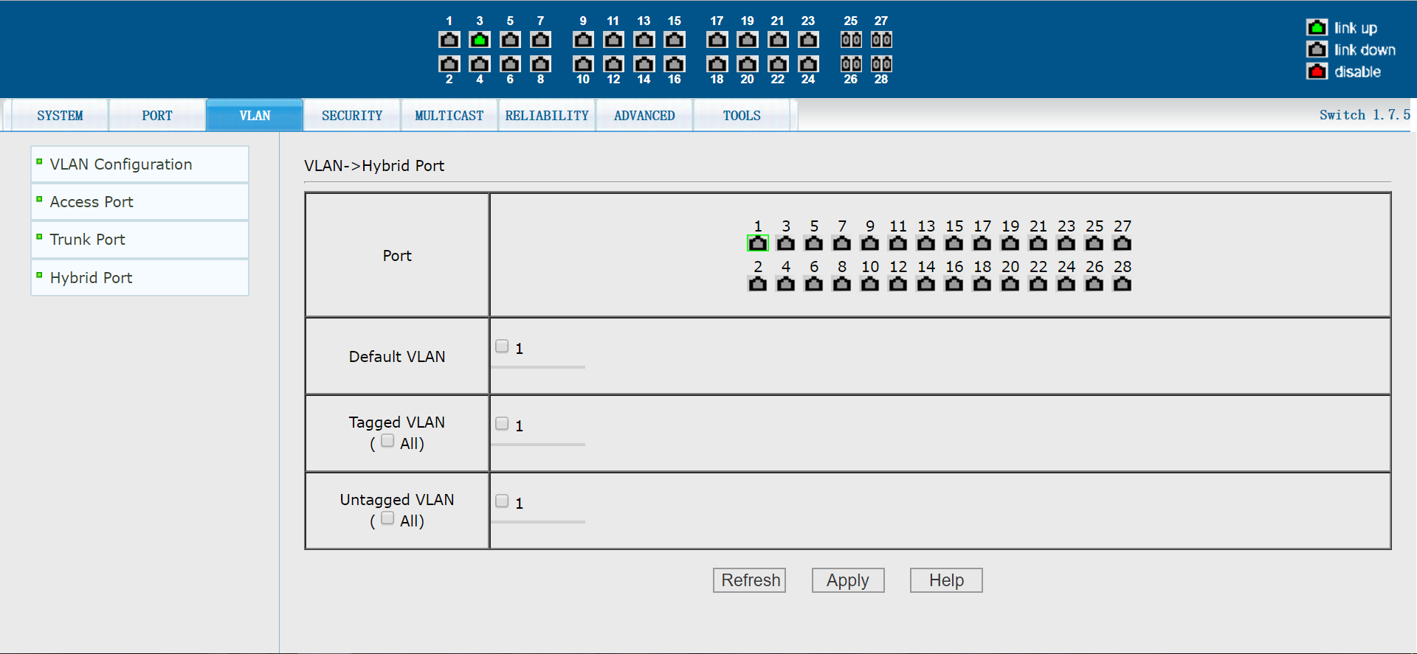
Figure 20 The Hybrid port configuration page

4. Safety configuration

(1) MAC configuration
MAC address manual binding page

Figure 21 is the MAC binding configuration page.This page is used to bind the port to the MAC address.
The MAC item on the page is used to enter the bound MAC address, and the VLAN ID item is used to enter the VLAN to which the MAC address belongs.
Figure 21. The MAC address is manually bound to the page

MAC address automatic binding page

Figure 22 shows the MAC address auto-binding page.This page is used to implement automatic port binding for MAC addresses.
Displays the existing dynamic MAC address and VLAN of the port in the second layer hardware transfer.You can select the entries and convert them to static bindings.
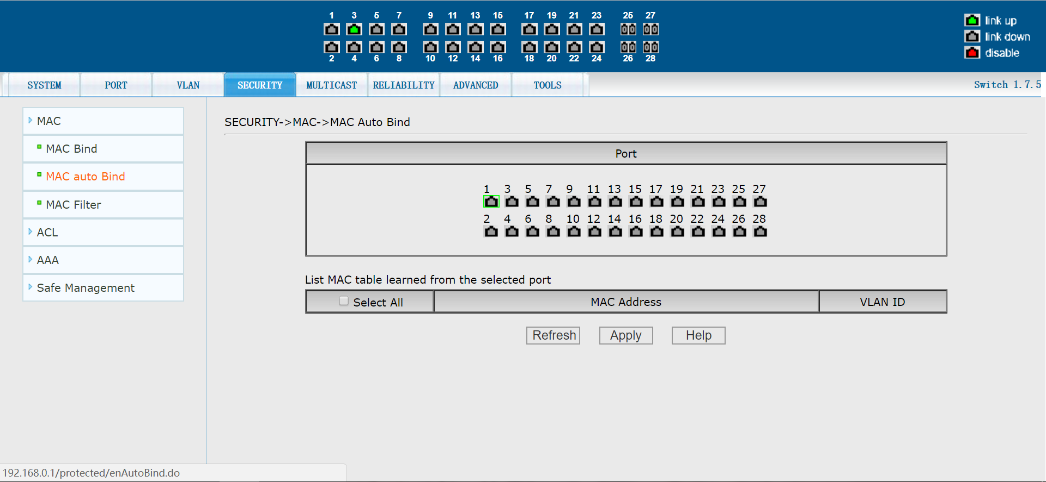

Figure 22. The MAC address automatically binds the page

MAC address filtering configuration page
Figure 23 is the MAC address filtering configuration page.This page is used to configure port filtering for MAC addresses.
The MAC entry on the page is used to enter the filtered MAC address, and the VLAN number entry is used to enter the VLAN to which the MAC address belongs.
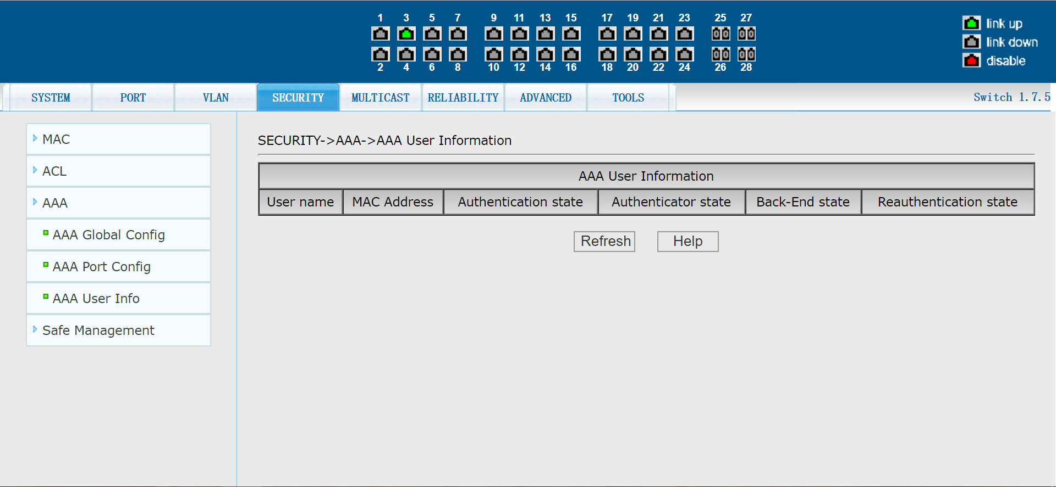
Figure 23. MAC address filtering configuration page

(2) ACL configuration
Standard IP group ACL page

Figure 24 is a standard IP group ACL page that allows users to create a rule base for the ACL standard IP.The user can select an ACL group number (ranging from 1-99, or 1300-1999) and create one or more rules in that group.The only fields that can be matched in a rule are the source IP address (with a mask).

Figure 24. The standard IP group ACL page

When a user configures a rule, the source IP address needs to be masked so that the rule can match the set of IP addresses.The address mask is represented by an inverse code. If the rule matches the IP address range 192.168.0.0 to 192.168.0.255, then the IP address can be
192.168.0.1, and its mask is.255.0.0.0
When users configure rules, each rule must have a filtering mode: allow or deny.
When a user creates a rule in a rule group, the system will automatically give the rule a rule number. When a rule in a rule group is deleted, the system will automatically sort the rules in a rule group if the other rules remain unchanged. To delete the entire rule group, the user selects all of them and then clicks the delete key.

Extend THE IP group ACL page

Figure 25 shows the extended IP group ACL page, where a user can create a rule base for an ACL extension IP.The user can select an ACL group number (ranging from 100 to 199, or 2000 to 2699) and create one or more rules in that group.The fields that can be matched in a rule are the active IP address (with mask), the destination IP address (with mask), the protocol type (such as ICMP, TCP, UDP, etc.), the source and destination ports (valid for TCP and UDP protocols only), and the TCP control flag.
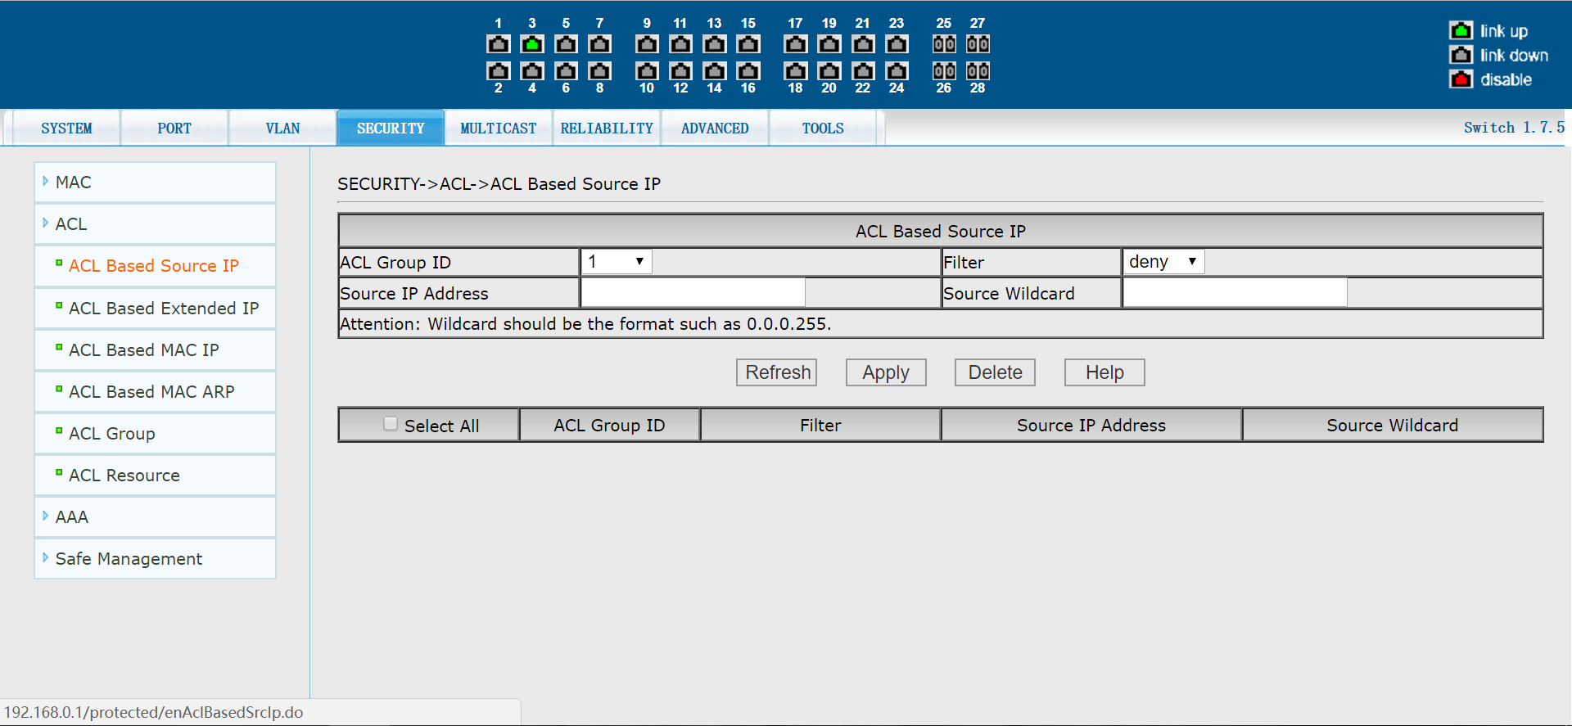
Figure 25 extends the IP group ACL page

When a user configures a rule, both the source IP address and the destination IP address need to be masked so that the rule can match the set of IP addresses.The address mask is represented by an inverse code. If the rule matches the IP address range 192.168.0.0 to 192.168.0.255, the IP address can be 192.168.0.1 and its mask is.255.0.0.0
When users configure rules, each rule must have a filtering mode: allow or deny.
When a user creates a rule in a rule group, the system will automatically give the rule a rule number. When a rule in a rule group is deleted, the system will automatically sort the rules in a rule group if the other rules remain unchanged. If the user wants to delete the entire rule group, he can select all of them first and then press the delete key.

MAC IP group ACL page

Figure 26 shows the MAC IP group ACL page, where a user can set up a rule base for the ACL MAC IP.The user can select an ACL group number (ranging from 700 to 799) and create one or more rules in that group.The fields that can be matched in a rule are the active MAC address (with the address matching bit), the source IP address (with the address matching bit), and the destination IP address (with the address matching bit).
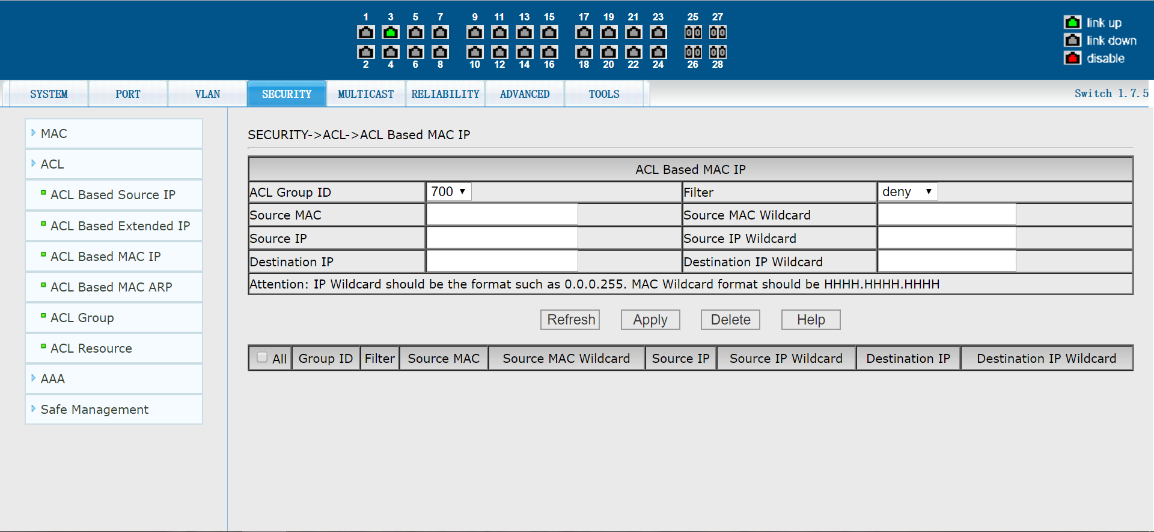
Figure 26. The MAC IP group ACL page

When a user configures a rule, the source MAC address, the source IP address, and the destination IP address all need address matching bits. The rule can match the set of MAC addresses and IP addresses.For example, if the rule matches the IP address range 192.168.0.0 to 192.168.0.255, the IP address can be 192.168.0.1 and its mask is.255.0.0.0
When users configure rules, each rule must have a filtering mode: allow or deny.
When a user creates a rule in a rule group, the system will automatically give the rule a rule number. When a rule in a rule group is deleted, the system will automatically sort the rules in a rule group if the other rules remain unchanged. If the user wants to delete the entire rule group, he can select all of them first and then press the delete key.

MAC ARP group ACL page

Figure 27 shows the ACL page for the MAC ARP group, where the user can set up a rule library for the ACL MAC ARP.The user can select an ACL group number (ranging from 1100 to 1199) and create one or more rules in that group.The fields that can be matched in a rule are the ARP operation type, send MAC address (with address matching bit), and send IP address (with address matching bit).
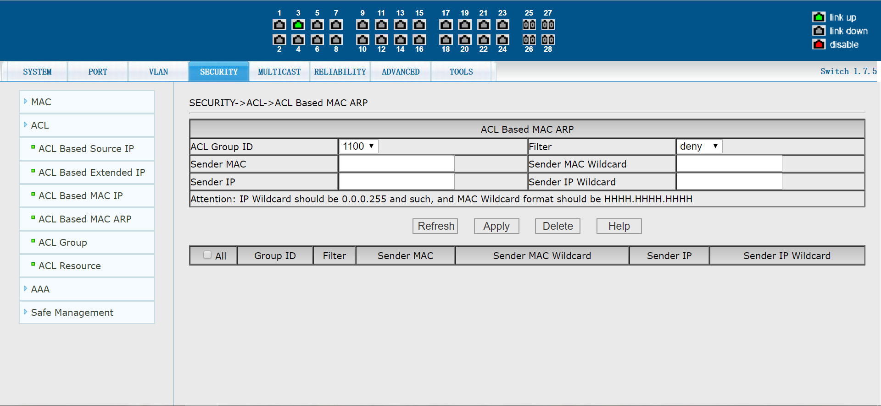
Figure 27. The MAC ARP group ACL configuration page

When a user configures a rule, the MAC address and the IP address both need to be matched with address matching bits. The rule can match the set of MAC addresses and IP addresses.For example, if the rule matches the IP address range 192.168.0.0 to 192.168.0.255, the IP address can be 192.168.0.1 and its mask is.255.0.0.0
When users configure rules, each rule must have a filtering mode: allow or deny.
When a user creates a rule in a rule group, the system will automatically give the rule a rule number. When a rule in a rule group is deleted, the system will automatically sort the rules in a rule group if the other rules remain unchanged. If the user wants to delete the entire rule group, he can select all of them first and then press the delete key.

Port application ACL page

Figure 28 is the port application ACL page, through which a user can select an ACL group for a port, write the rules in this ACL group into the port hardware logic, and cause the port to perform ACL filtering on the received packets based on these rules.
When selecting the ACL group on the port, you can select the IP Standard, IP extension, MAC IP, and MAC ARP ACL groups. The selected ACL group must exist. Select from the LIST of ACL rule groups and press the add key.When deleting an ACL group, select an ACL group from the list of referenced rule groups and press the delete key.
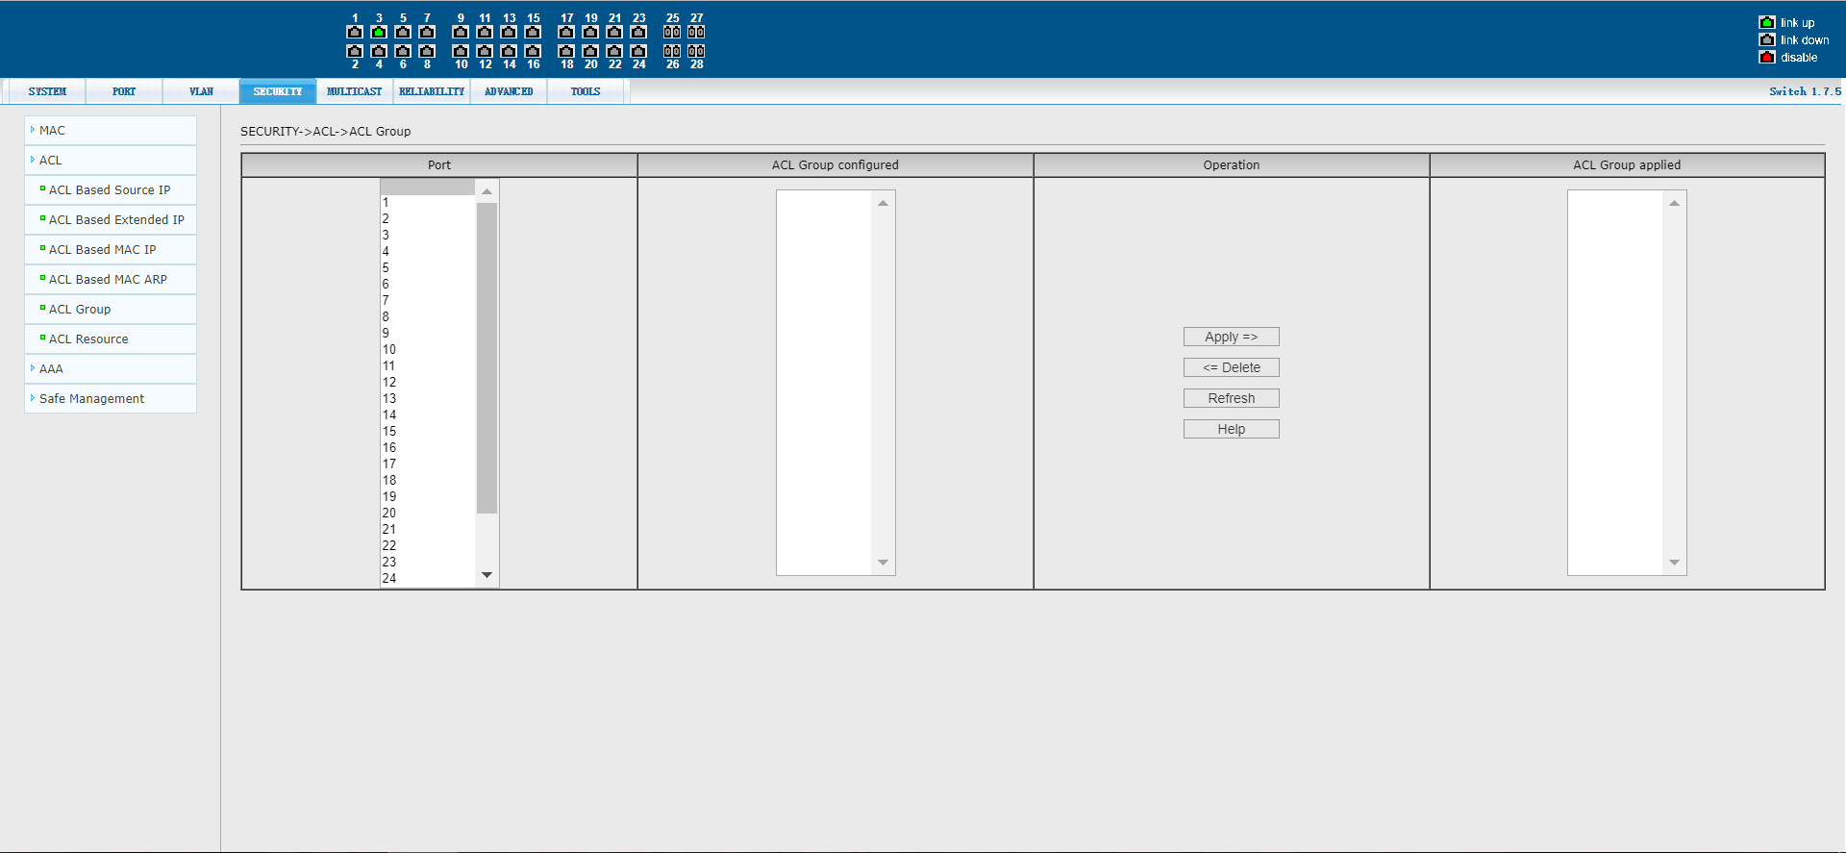
Figure 28 applies the ACL page on port 28

ACL configuration information page

Figure 29 is the ACL configuration information page, which displays information about all the rules and references configured in the current ACL.
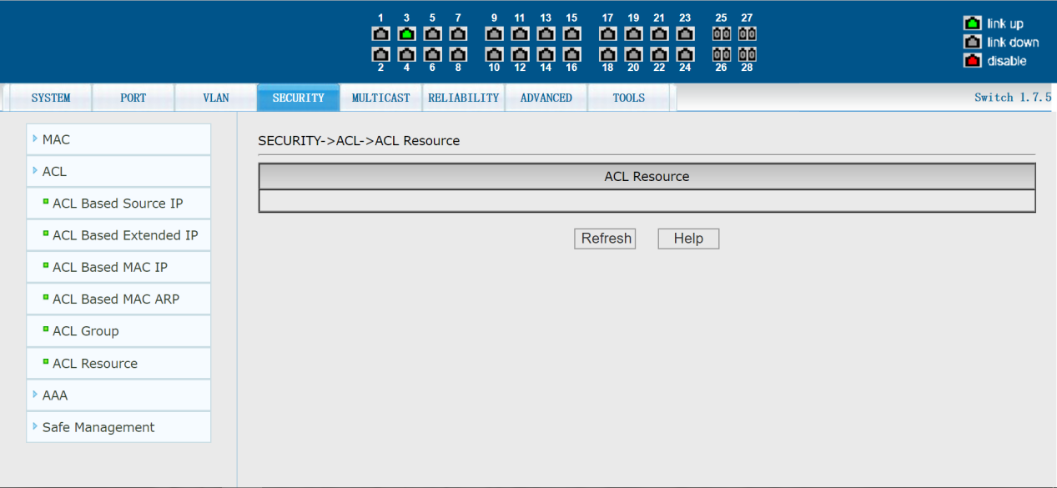
Figure 29 ACL configuration information page

(3) AAA configuration
AAA global configuration page

Figure 30 is the AAA global configuration page. Users can configure information related to AAA. Information that can be set includes:
-  whether start the 802.1 x protocol, when doing the authentication billing must start the 802.1 x protocol.
-   Whether open authentication function again, not opened by default, when doing the authentication billing according to the actual situation to decide.Turning on recertification will make the user more reliable when using authentication billing, but will increase the traffic on the network slightly.
-   Set to certification time interval, only in the case of authentication is enabled again, the default is 3600 seconds, when doing the authentication billing according to the actual situation to set the value, but the value is not too small.
- The IP address of the RADIUS server, which must be set when doing authentication billing.
-   Spare the RADIUS server IP address, if you have spare the RADIUS server can set this field.
-   Shared secret key, which is used to set the switch between the Radius server and the encryption of the Shared password, when doing the authentication billing must set this field, and to set the Radius server.
-   Whether to start charging, the default is to start, when doing the authentication billing to start pricing in general.
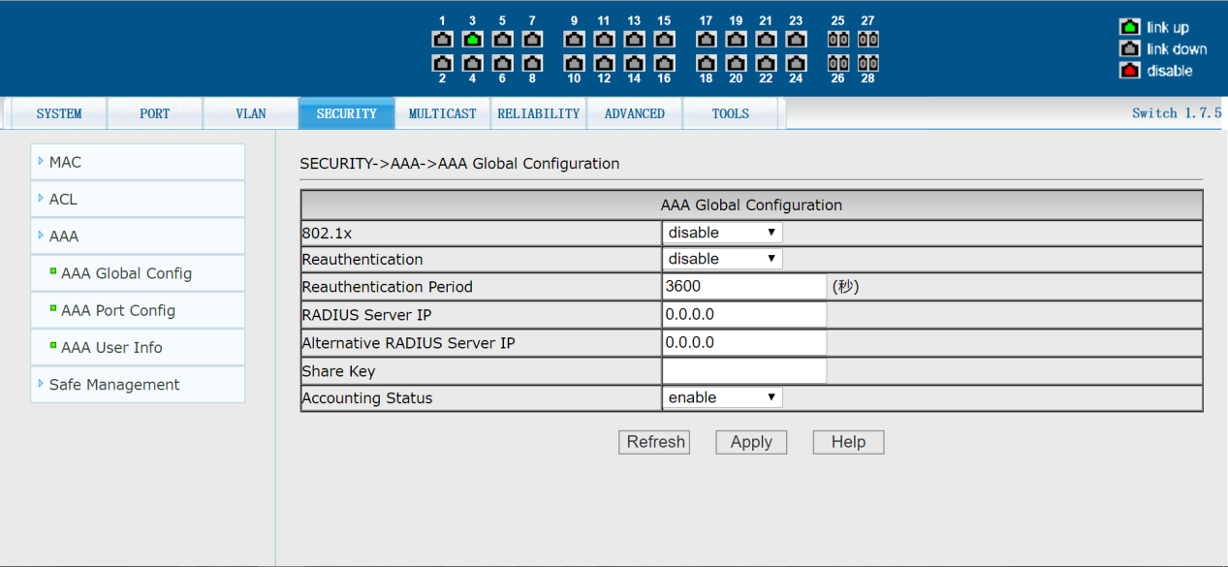
Figure 30 The AAA global configuration page

AAA port configuration page

Figure 31 is the AAA port configuration page, through which users can configure the authenticated port mode and the maximum number of supported hosts, and view the configuration of each port.To modify the PORT AAA configuration, users need to check on the left side of the corresponding port, or use the "all select" function. The selected port will be displayed at the top of the page, with successive ports represented by connection Numbers.After successful setup, the selected port will be configured with the same parameters.The AAA port mode includes four types: N/A status, Auto status, Force-Authorized status, and Force-UNAUTHORIZED status.When A port needs to be authenticated by 802.1x, the port should be set to Auto state. If the network can be accessed without authentication, the port should be set to N/A state. The other two states are rarely used in practical applications.
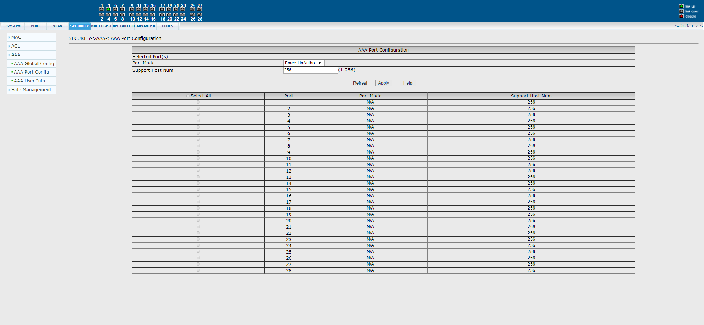
Figure 31. AAA port configuration page
When doing 802.1X authentication, the default port access maximum number of hosts is 256, users can modify this field, can support up to 256.

AAA user information page

Figure 32 is the AAA user information page, through which users can view the status information of all users accessed under a certain port.
Figure 32 AAA user information page

(4) This machine manages security configuration
Manage permission configuration page

Figure 33 is the administrative permissions configuration page, through which administrators can control the network management services TELNET, WEB, and SNMP, enable or disable these services, hook these services up to the IP standard ACL groups, enforce source IP address control, and control host access to these services.
By default, the TELNET, WEB, and SNMP services of the switch are turned on without ACL filtering, meaning that all hosts can access these three services of the switch.If the administrator does not want to provide one or more of these services to other users for security reasons, he can turn off one or more of these services. If an administrator only wants a particular host to have access to one or more of these services, ACL filtering can be done for one or more of these services.When a service wants to do ACL filtering, the service needs to be opened and an IP-standard ACL group (1-99) is selected, at which point the ACL group must exist.
It is important to note that if the administrator controls the WEB service on this page (such as turning off the WEB service) and the user can no longer use the WEB page, there are other ways to log in to the switch and control the WEB service to enable the user to use the WEB page(such as opening the WEB service). 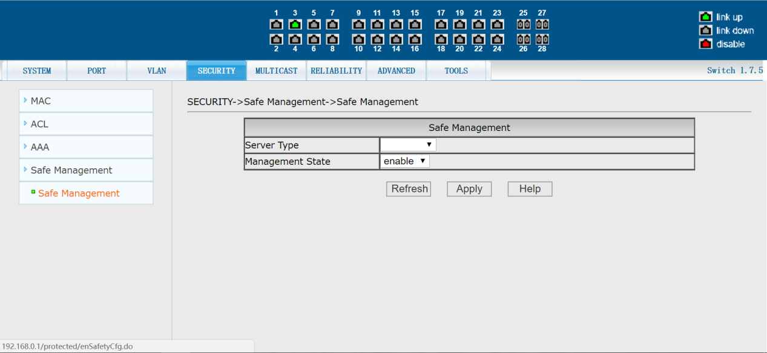

Figure 33 administrative rights new configuration page

5. Multicast configuration

(1) IGMP SNOOPING Configuration
IGMP SNOOPING Configuration page
Figure 34 shows the IGMP SNOOPING Configuration page.Users can enable IGMP Snooping through this page. 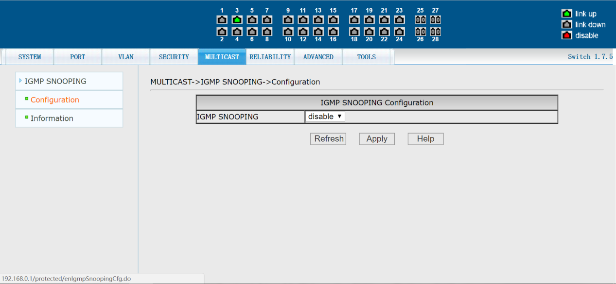

Figure 34 IGMPSNOOPING Configuration page

Multicast group information page

Figure 35 is the multicast group information page, where users can view the IGMP SNOOPING Group information.

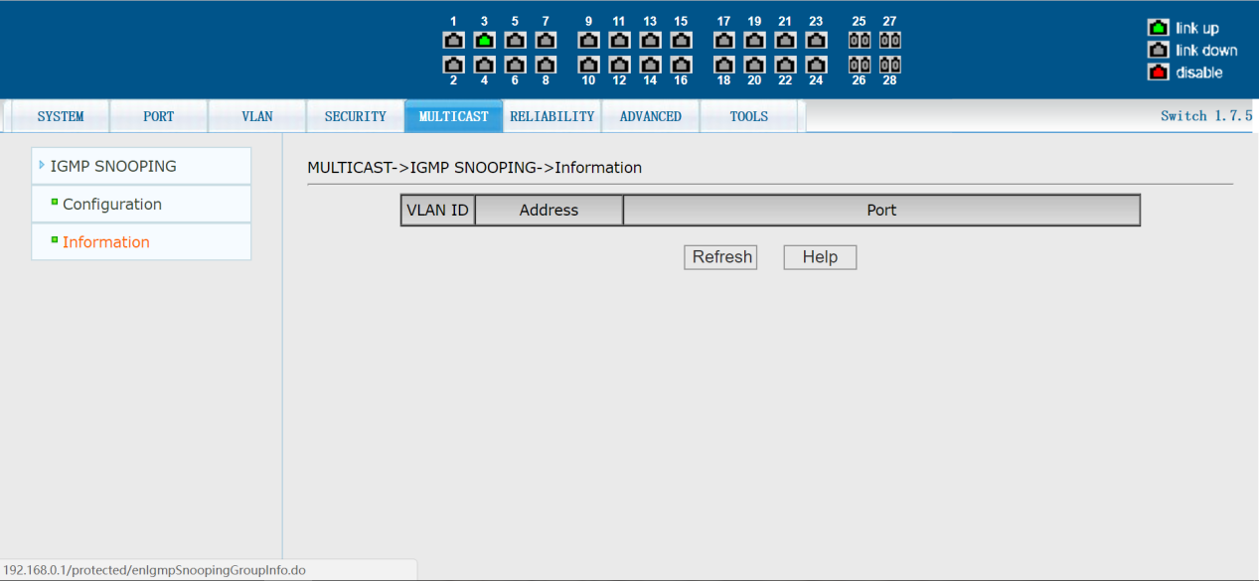

Figure 35 Multicast group information page

6. Reliability application

(1) Configuration of spanning tree
Spanning tree global configuration page

Figure 36 is the spanning tree global configuration page, where users can configure the global spanning tree parameters.

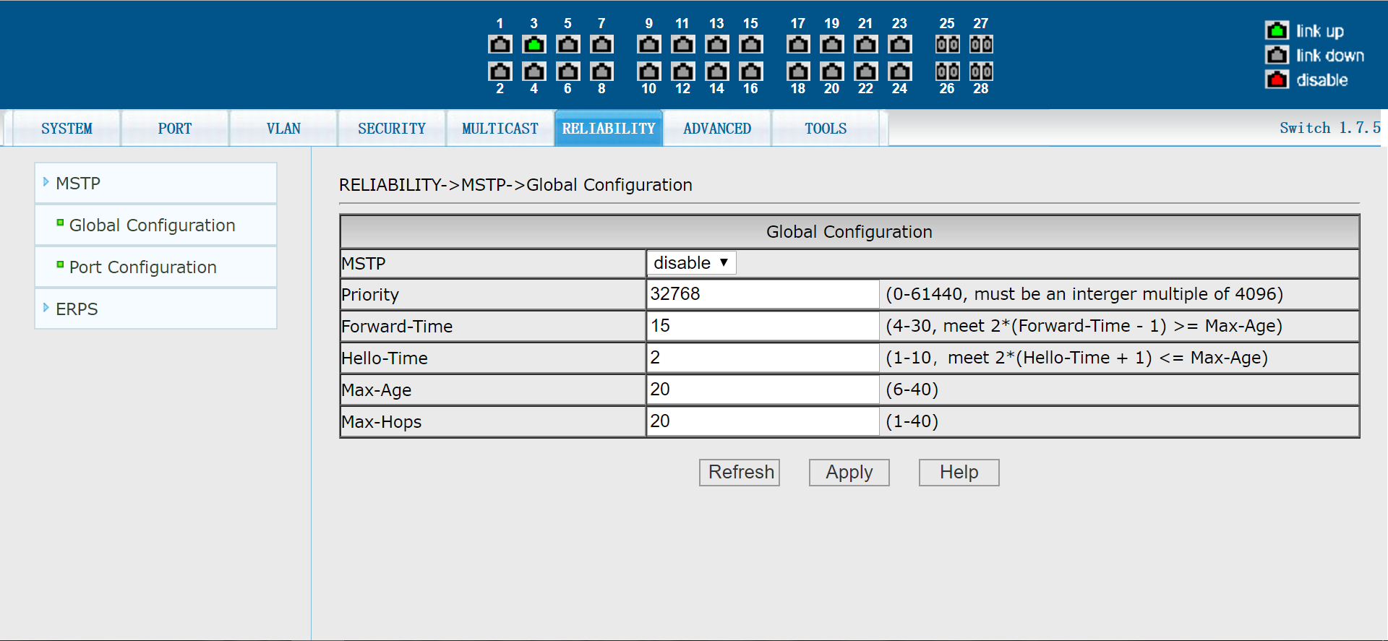
Figure 36 Spanning tree global configuration page

Spanning tree port configuration page

Figure 37 is the spanning tree port configuration page, through which users can view the specific status of port MSTP.
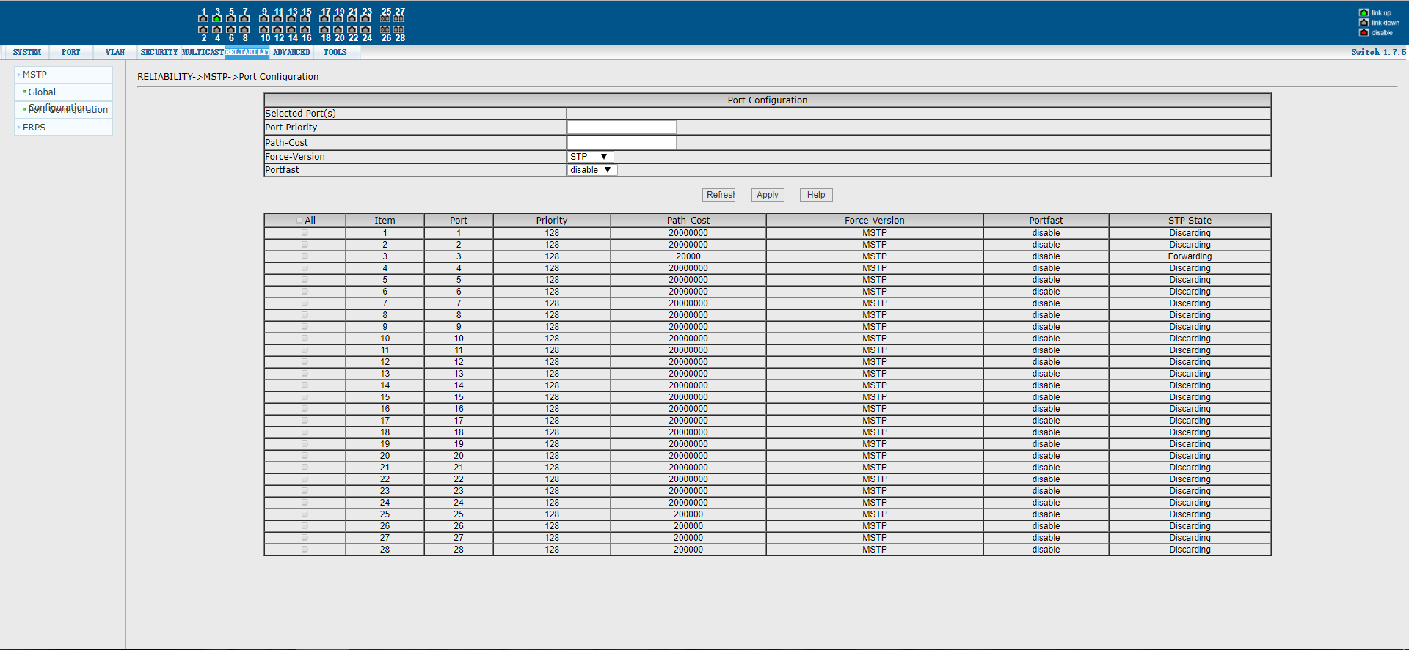
Figure 37. Spanning tree port configuration page

(2) ERPS configuration
ERPS pre-defined configuration page

Figure 38 is the ERPS predefined configuration page, which enables the ERPS predefined configuration.When ERPS pre-configuration is enabled, you can specify the node type: primary or transport node.
Specific predefined configuration: ERPS instance number is 1, ERPS in # 1, ring mode is given priority to ring, agreement VLAN for VLAN3001, data VLAN for VLAN1, RPL port of 51, rl port for 52, restoring behavior is recoverable, hold - off time of 0, guard time of 500 milliseconds, WTR time is 5 points, WTB time allows for 5 seconds, agreement message sending time for 5 seconds.
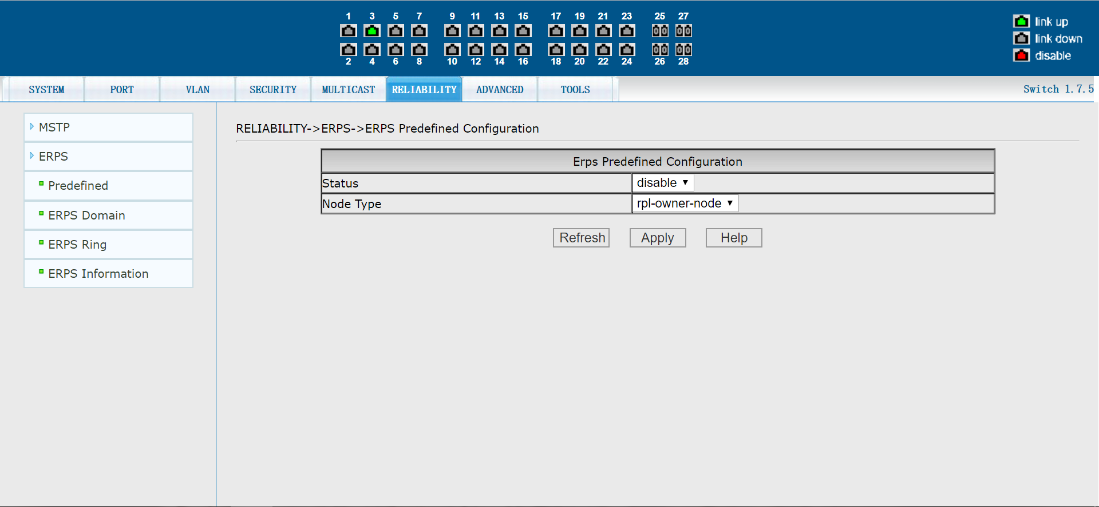

Figure 38. ERPS Predefined configuration page

ERPS instance configuration page

Figure 39 shows the ERPS instance configuration page through which an ERPS instance can be configured.If the instance is not created, click the Apply button to create and specify the role; When an instance is created but not yet associated with a ring, the role can be modified; If an instance has been created and a ring is associated, it cannot be modified.Click the delete button to delete the selected instance.Up to eight instances can be configured.
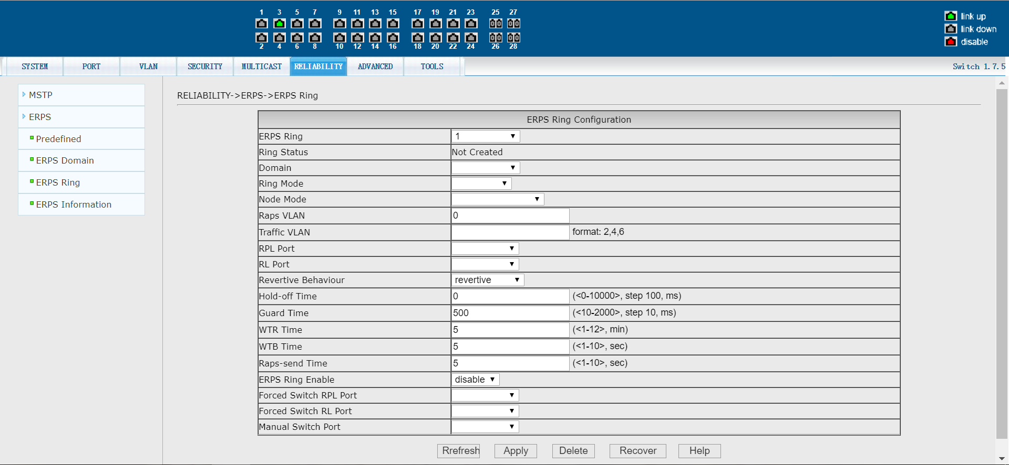
Figure 39. ERPS instance configuration page

ERPS ring configuration page

Figure 40 shows the ERPS ring configuration page through which the ERPS ring can be created and configured.Select a ring. Click the Apply button when the ring is not created to create the ring and set the configuration information. Once created, the configuration information can be modified.Click the delete button to delete the selected ring.Rings must be associated with only one instance, and a maximum of 32 rings can be configured.When a ring failure is detected, click the manual restore button to restore.
Figure 40. ERPS ring configuration page

ERPS information page

Figure 41 is the ERPS information page. Selecting the ring number will display the configuration and status information of the relevant ERPS rings.
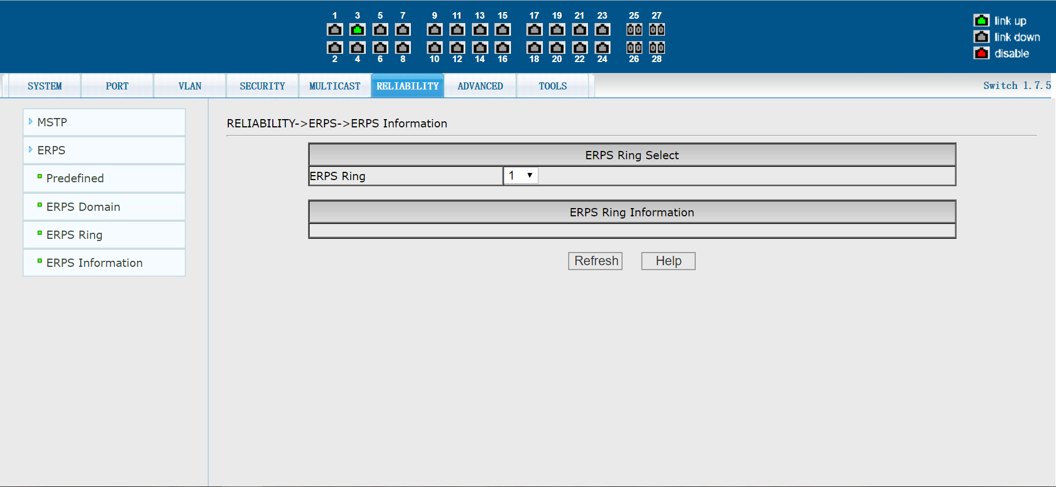
Figure 41. ERPS information page

7. Advanced configuration

(1) Basic IP configuration
VLAN interface configuration page

Figure 42 is the VLAN interface configuration page, through which users can configure the IP address of the interface, delete the IP address of the interface, and view the interface information.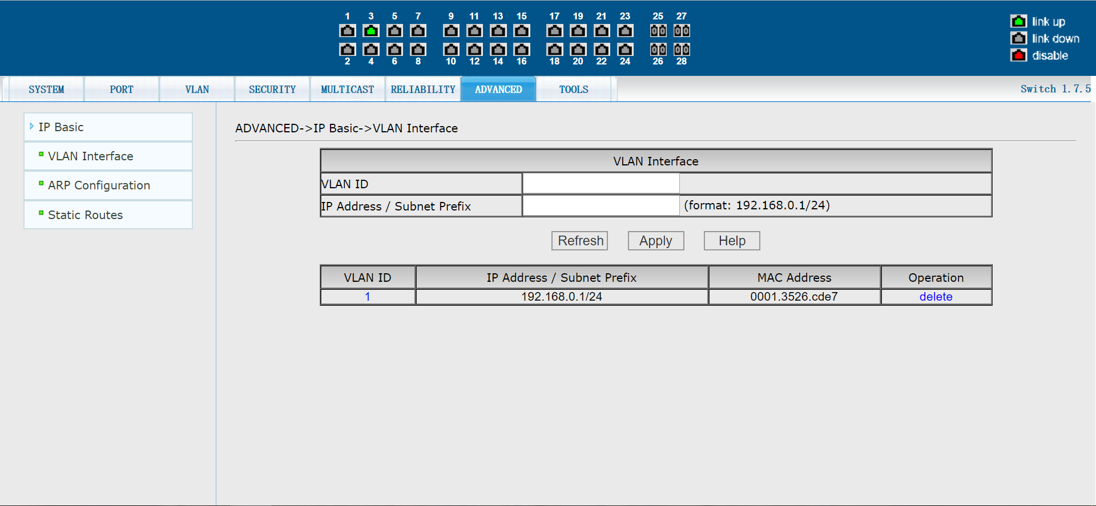

Figure 42 VLAN interface configuration page
Switch has a VLAN1 interface by default, which cannot be deleted.A VLAN can only be configured with one interface.

ARP configuration page

Figure 43 is the ARP configuration page, which can display all the ARP table information of the switch. At the same time, users can configure static ARP entries, delete ARP entries, and change dynamic ARP table entries to static ARP table entries through this page.
When configuring a static ARP entry, the user enters the IP address and MAC address, the MAC address must be a unicast MAC address, and then clicks the Apply button.
When the user is deleting an ARP entry, click the corresponding delete link in the list.
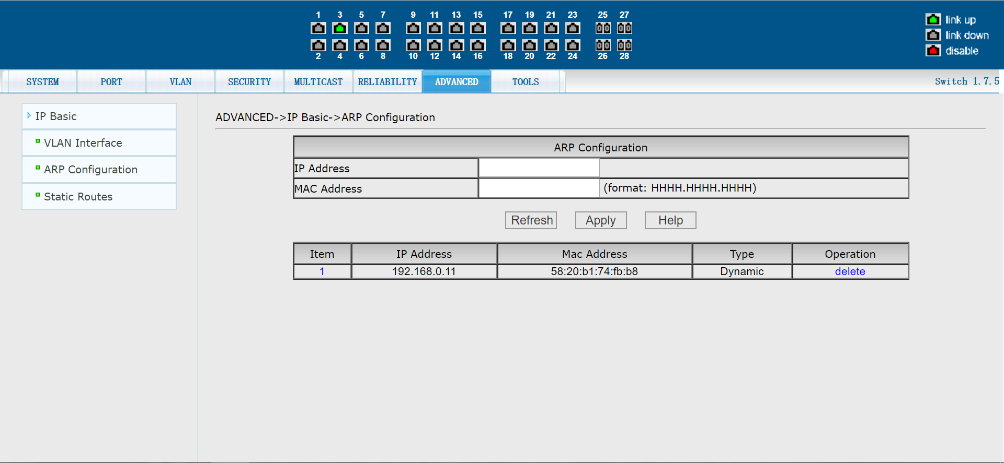
Figure 43: ARP configuration page

Static route configuration page

Figure 44 is the static route configuration page, where users can add and remove static routes of the switch.By default, the switch is not configured with static routing. Users can configure the default route through this page, that is, the destination address/subnet is prefixed with.0/0.0.0.0
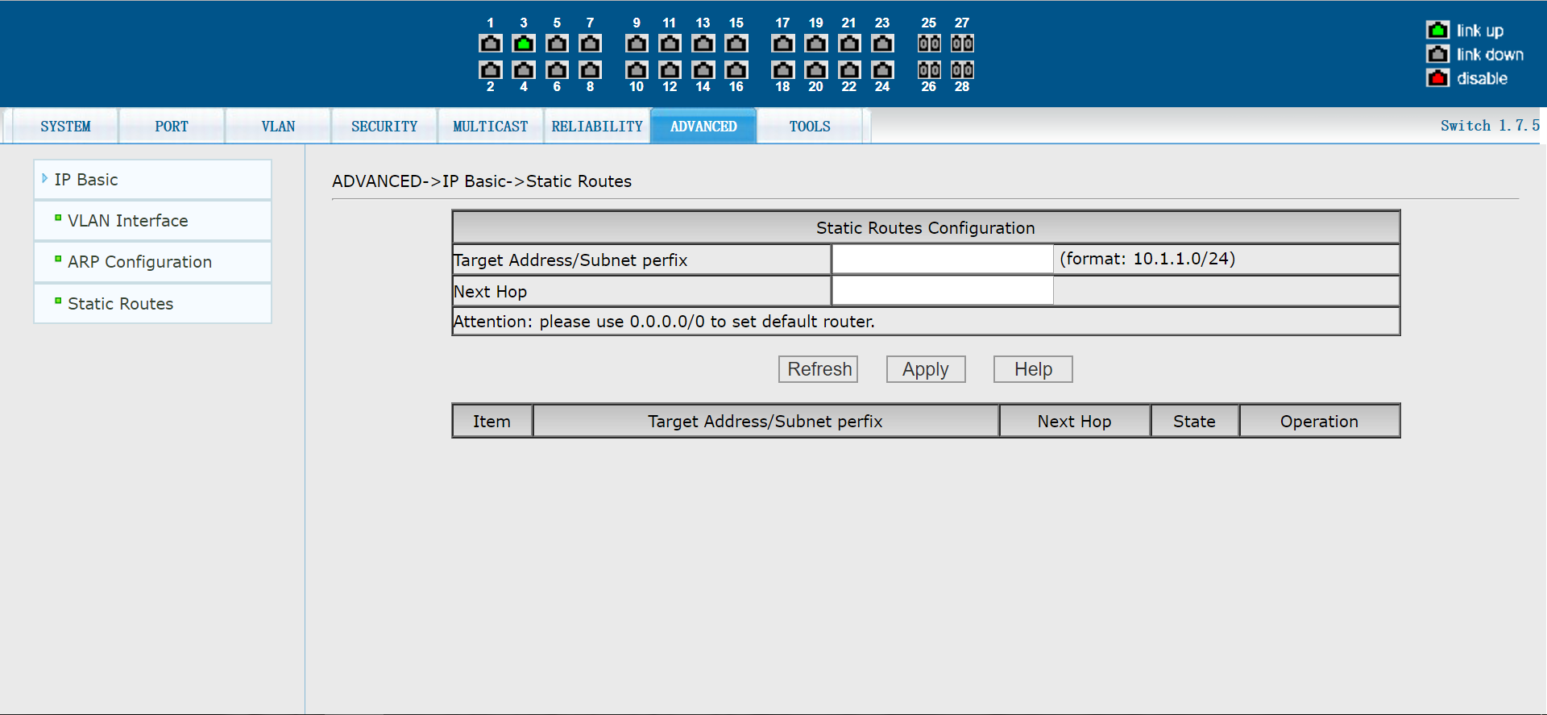
Figure 44 Static route configuration page

8. System tools
(1) Save the configuration page

Figure 45 shows the save configuration page.This page allows users to view the current configuration of the switch.The save button stores the current configuration of the system in a configuration file.Because storage operations require wiping the FLASH chip, this can take some time.When the user has made a configuration on the page and wants it not to be lost after restarting the switch, he must click the save button in the current configuration page before exiting the page.

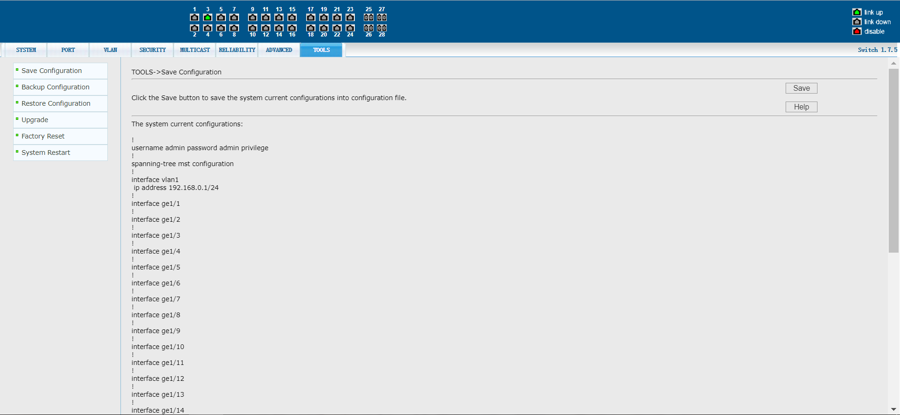

Figure 45 saves the configuration page

(2) Backup configuration file pages

Figure 46 shows the backup configuration file page.This page allows the user to view the initial configuration of the system.The initial configuration is essentially a configuration file in FLASH, and when no configuration file exists in FLASH, the system starts with the default configuration.Clicking the backup button will bring up a dialog box. The user selects the directory path of the disk and saves the configuration file.The default file name of the downloaded configuration file is switch.cfg.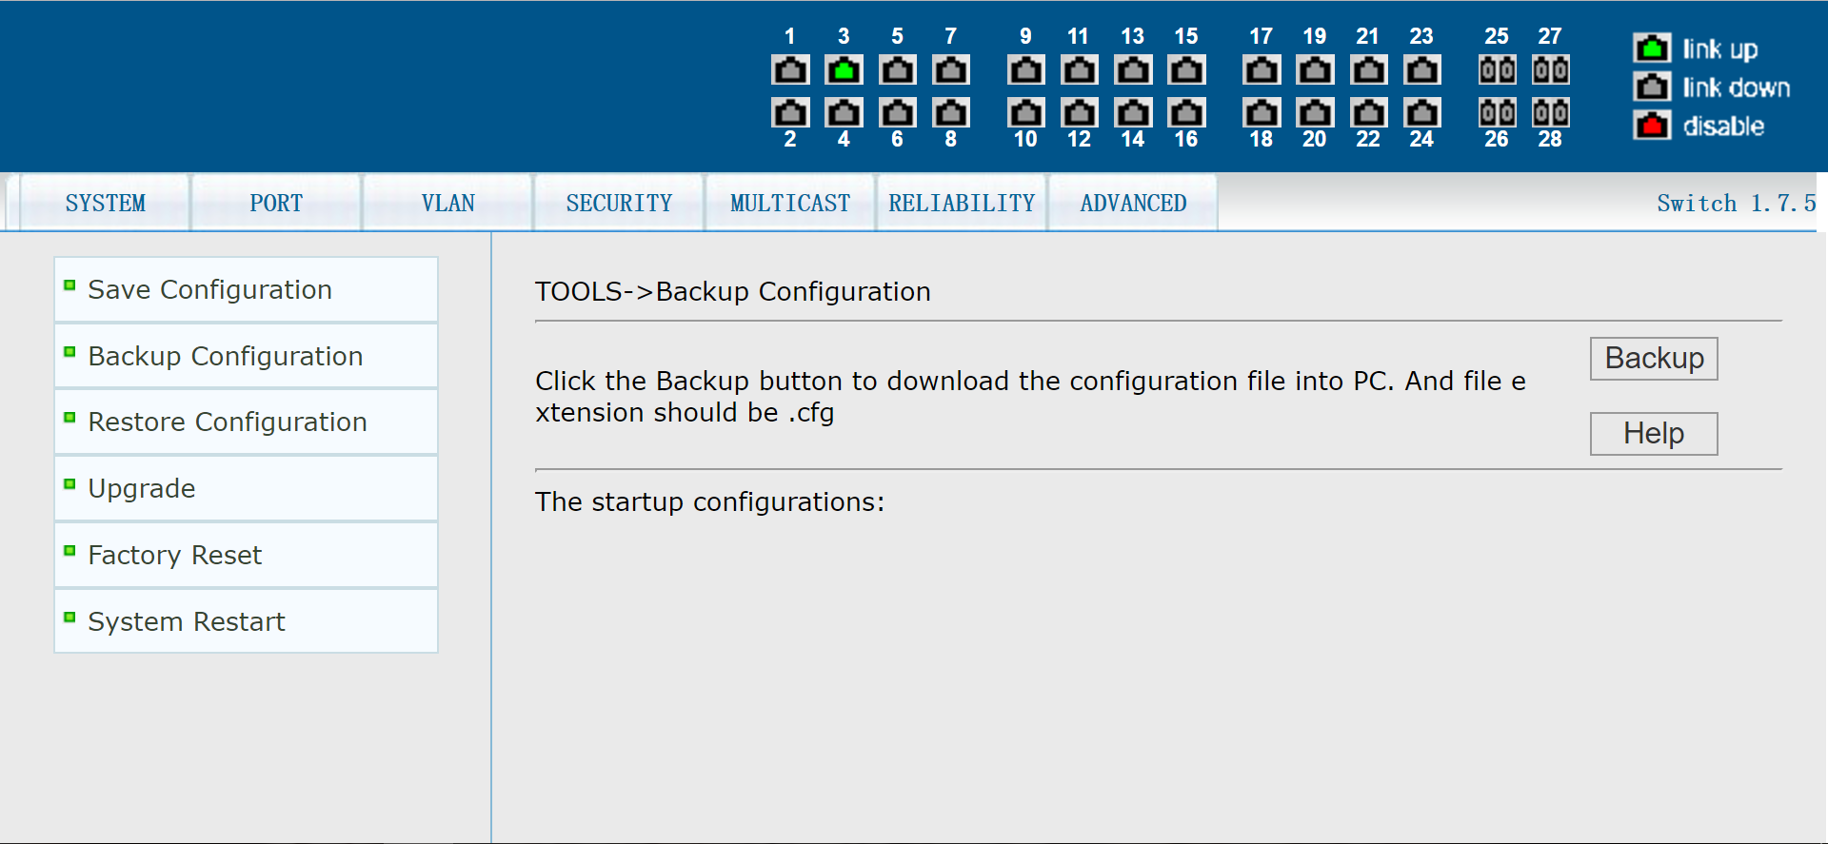

Figure 46 Backup configuration file page

(3) Restore the configuration file page

Figure 47 shows the restore profile page, where users can upload profiles to the switch.Click the Browse button to select the directory path of the uploaded profile on the PC.Click the Upload button to upload the configuration file. The suffix of the configuration file must be *.cfg.Please do not click other pages or restart the switch before the transmission result page returns; Otherwise, file transfer failure will result in system crash.
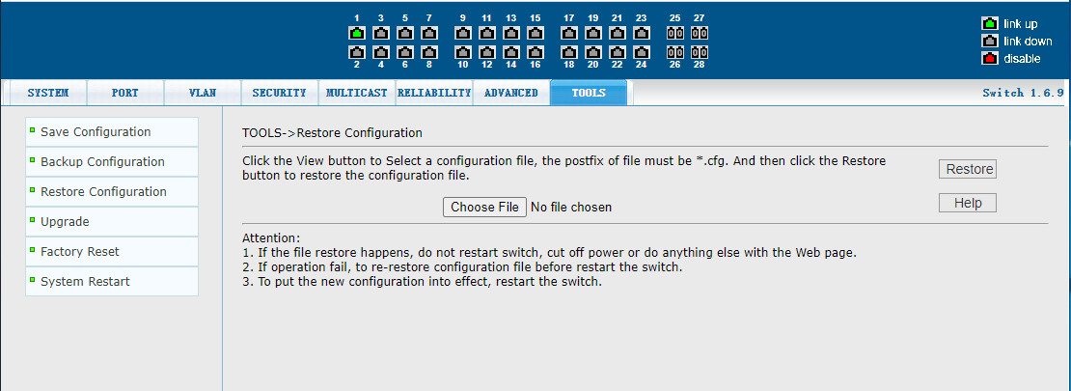
Figure 47 Restoring the profile page

(4) Software upgrade page

Figure 48 is the software upgrade page, through which users can upload image files to the switch.Click the Browse button to select the directory path of the uploaded image file on your PC.Click the Upload button to upload the image file, which must be supplied by the manufacturer and the filename suffix must be *.img.Please do not click other pages or restart the switch before the transmission result page returns; Otherwise, file transfer failure will result in system crash.
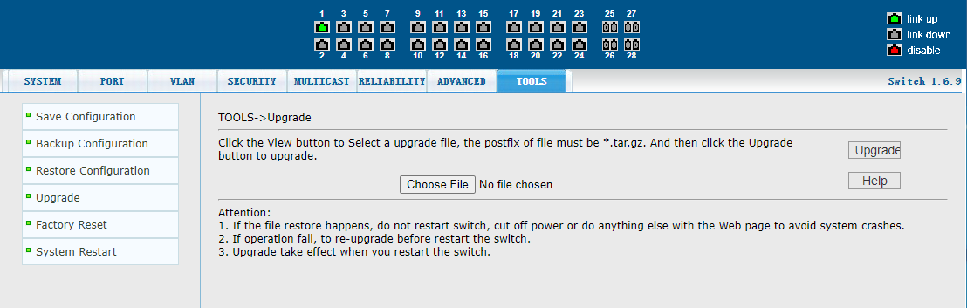
Figure 48 Software upgrade page

(5) Restore factory configuration page

Figure 49 shows the restore factory configuration page.This page allows the user to delete a configuration file in FLASH to restore the factory configuration.Click the restore factory configuration button, a dialog box will pop up, prompting the user whether to confirm.After resuming the factory configuration, the switch will restart automatically to make the factory configuration take effect. Please use the default factory IP address and password when logging in next time.

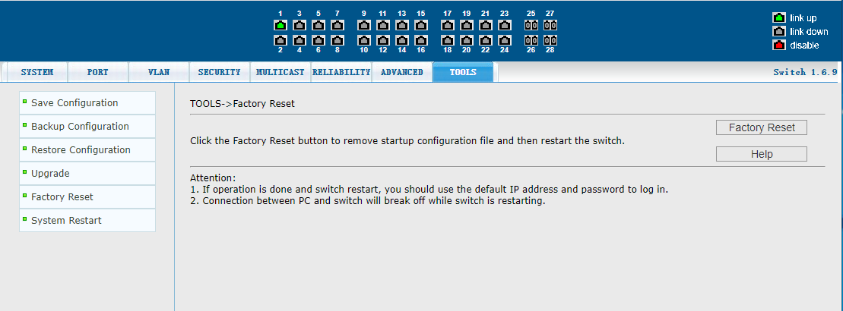

Figure 49 Restoring the factory configuration page

(5) Restart the page

Figure 50 shows the restart page through which the user restarts the switch.When the restart key is clicked, a dialog box will pop up, prompting the user to confirm whether to restart the switch. If yes, press the OK key; otherwise, press the cancel key. The Web page will no longer open on reboot.

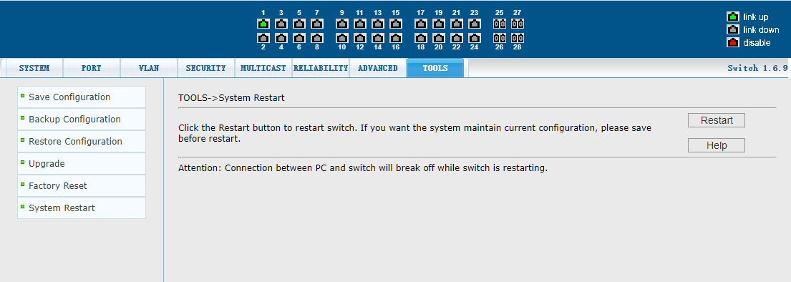

Figure 50. Restart the page

